Hamza
24k-3065
Lab-10

Q2:

#include <iostream>
using namespace std;

class Node {
public:
int data;
Node *left;
Node *right;
int height;

Node(int d) {
data = d;
left = right = NULL;
height = 0;
}
};

int maxi(int a, int b) {
return (a > b) ? a : b;
}

int give_height(Node *root) {
if (root == NULL) return -1;
return 1 + maxi(give_height(root->left), give_height(root->right));
}

int bf(Node *root) {
if (root == NULL) return 0;
return give_height(root->left) - give_height(root->right);
}

Node* right_rotate(Node *root) {
Node *x = root->left;
Node *temp = x->right;
x->right = root;
root->left = temp;
root->height = give_height(root);
x->height = give_height(x);
return x;
}

Node* left_rotate(Node *root) {
Node *x = root->right;
Node *temp = x->left;
x->left = root;
root->right = temp;
root->height = give_height(root);
x->height = give_height(x);
return x;
}

Node* minValueNode(Node* root) {
Node* current = root;
while (current->left != NULL)
current = current->left;
return current;
}

Node* insert(Node *root, int d) {
if (root == NULL)
return new Node(d);

if (d < root->data)
root->left = insert(root->left, d);
else if (d > root->data)
root->right = insert(root->right, d);
else
return root;

root->height = give_height(root);
int b = bf(root);

if (b < -1) {
if (d > root->right->data)
return left_rotate(root);
else {
root->right = right_rotate(root->right);
return left_rotate(root);
}
}

if (b > 1) {
if (d < root->left->data)
return right_rotate(root);
else {
root->left = left_rotate(root->left);
return right_rotate(root);
}
}

return root;
}

void inorder(Node *root) {
if (root == NULL) return;
inorder(root->left);
cout << root->data << " ";
inorder(root->right);
}

int main() {
Node *root = NULL;
root = insert(root, 50);
root = insert(root, 30);
root = insert(root, 70);
root = insert(root, 20);
root = insert(root, 40);
root = insert(root, 60);
root = insert(root, 80);
cout << "Before rotation: ";
inorder(root);
cout << endl;
root = insert(root, 55);

cout << "After rotation: ";
inorder(root);
cout << endl;

return 0;
}
Q3:

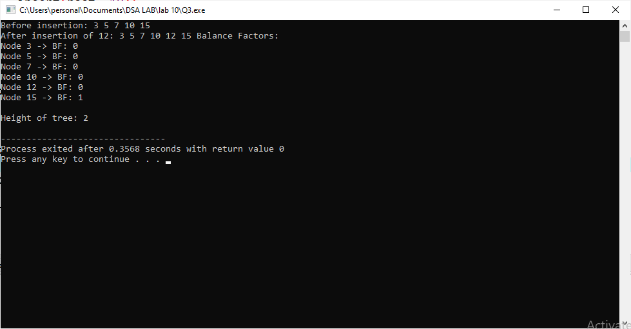
#include <iostream>
using namespace std;

class Node {
public:
int data;
Node *left;
Node *right;
int height;

Node(int d) {
data = d;
left = right = NULL;
height = 0;
}
};

int maxi(int a, int b) {
return (a > b) ? a : b;
}

int give_height(Node *root) {
if (root == NULL) return -1;
return 1 + maxi(give_height(root->left), give_height(root->right));
}

int bf(Node *root) {
if (root == NULL) return 0;
return give_height(root->left) - give_height(root->right);
}

Node* right_rotate(Node *root) {
Node *x = root->left;
Node *temp = x->right;
x->right = root;
root->left = temp;
root->height = give_height(root);
x->height = give_height(x);
return x;
}

Node* left_rotate(Node *root) {
Node *x = root->right;
Node *temp = x->left;
x->left = root;
root->right = temp;
root->height = give_height(root);
x->height = give_height(x);
return x;
}

Node* insert(Node *root, int d) {
if (root == NULL)
return new Node(d);
if (d < root->data)
root->left = insert(root->left, d);
else if (d > root->data)
root->right = insert(root->right, d);
else
return root;
root->height = give_height(root);
int b = bf(root);
if (b < -1) {
if (d > root->right->data)
return left_rotate(root);
else {
root->right = right_rotate(root->right);
return left_rotate(root);
}
}
if (b > 1) {
if (d < root->left->data)
return right_rotate(root);
else {
root->left = left_rotate(root->left);
return right_rotate(root);
}
}
return root;
}

void inorder(Node *root) {
if (root == NULL) return;
inorder(root->left);
cout << root->data << " ";
inorder(root->right);
}

void printBF(Node *root) {
if (root == NULL) return;
printBF(root->left);
cout << "Node " << root->data << " -> BF: " << bf(root) << endl;
printBF(root->right);
}

int main() {
Node *root = NULL;
root = insert(root, 10);
root = insert(root, 5);
root = insert(root, 15);
root = insert(root, 3);
root = insert(root, 7);
cout << "Before insertion: ";
inorder(root);
cout << endl;
root = insert(root, 12);
cout << "After insertion of 12: ";
inorder(root);
cout << "Balance Factors:" << endl;
printBF(root);
cout << endl << "Height of tree: " << give_height(root) << endl;
return 0;
}

